**Lab Report 2**

*Course title: Computer Graphics Laboratory*

*Course code: CSE-304*

*3rd Year 1st Semester*

**Date of Submission**: 4/6/2023

**Submitted to-**

**Dr. Mohammad Shorif Uddin**

**Professor**

**Dr. Morium Akter**

**Associate Professor**

*Department of Computer Science and Engineering*

*Jahangirnagar University Savar, Dhaka-1342*

|  |  |  |  |
| --- | --- | --- | --- |
| **Sl** | Class Roll | Exam Roll | Name |
| 01 | 384 |  | Taufiq Islam |

Department of Computer Science and Engineering

Jahangirnagar University

Savar, Dhaka, Bangladesh

# Scan convert a circle using midpoint algorithm:

Source Code:

#include<bits/stdc++.h>

#include<graphics.h>

int main()

{

float x,y,r;

int sx,sy,sr;

printf("Enter center point(x,y): ");

scanf("%f %f",&x,&y);

sx = floor(x);

sy = floor(y);

printf("Enter radius: ");

scanf("%f",&r);

sr = floor(r);

int dx = 0;

int dy = sr;

int d = 1 - sr;

int gd= DETECT, gm;

initgraph(&gd,&gm,"");

while(dx <= dy)

{

putpixel(sx+dx,sy+dy,WHITE);

putpixel(sx-dx,sy+dy,WHITE);

putpixel(sx+dx,sy-dy,WHITE);

putpixel(sx-dx,sy-dy,WHITE);

putpixel(sx+dy,sy+dx,WHITE);

putpixel(sx-dy,sy+dx,WHITE);

putpixel(sx+dy,sy-dx,WHITE);

putpixel(sx-dy,sy-dx,WHITE);

if(d < 0)

{

d += 2*dx + 3;

}

else

{

d += (2 * (dx - dy)) + 5;

dy--;

}

dx++;

}

getch();

closegraph();

return 0;

}

Output:

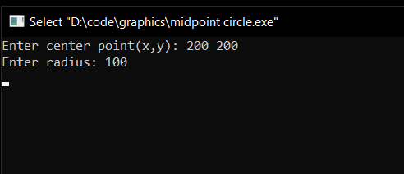

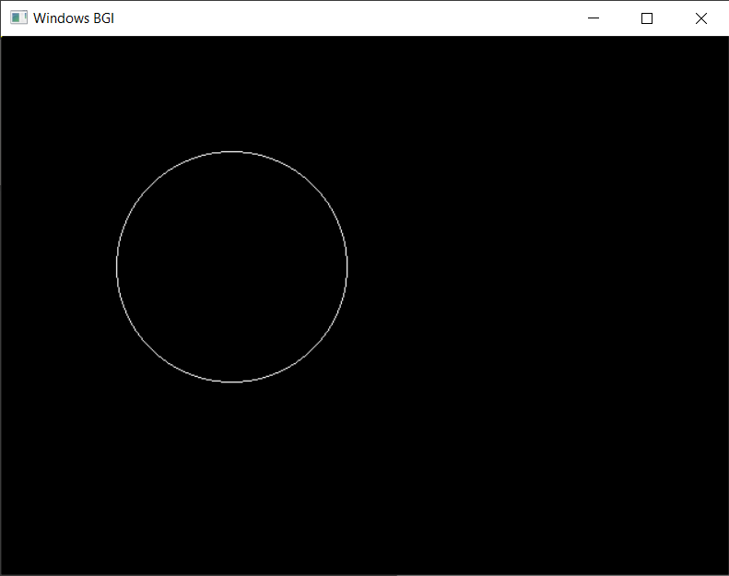

## Scan converting an ellipse using midpoint algorithm:

Source Code:

#include<bits/stdc++.h>

#include<graphics.h>

void setpix(int sx,int sy,int dx,int dy)

{

putpixel(sx+dx,sy+dy,WHITE);

putpixel(sx+dx,sy-dy,WHITE);

putpixel(sx-dx,sy+dy,WHITE);

putpixel(sx-dx,sy-dy,WHITE);

}

int main()

{

float x,y,r,a,b;

int sx,sy,sa,sb;

printf("Enter center point(x,y): ");

scanf("%f %f",&x,&y);

sx = floor(x);

sy = floor(y);

printf("Enter major axis: ");

scanf("%f",&a);

printf("Enter minor axis: ");

scanf("%f",&b);

sa = floor(a);

sb = floor(b);

int dx = 0;

int dy = sb;

int aa,bb,aa2,bb2;

aa = sa*sa;

bb = sb*sb;

aa2 = aa * 2;

bb2 = bb * 2;

int fx = 0,fy = aa2*sb;

int d = bb - aa*b + round(0.25*aa);

int gd= DETECT, gm;

initgraph(&gd,&gm,"");

while(fx < fy)

{

setpix(sx,sy,dx,dy);

dx++;

fx += bb2;

if(d < 0)

{

d += fx + bb;

}

else

{

dy--;

fy -= aa2;

d += fx + bb - fy;

}

}

setpix(sx,sy,dx,dy);

d = round(bb *(dx+0.5) * (dx+0.5)) + (aa * (dy-1) * (dy-1)) - aa*bb;

while(dy > 0)

{

dy--;

fy -= aa2;

if(d >= 0)

{

d = d - fy + aa;

}

else

{

dx++;

fx += bb2;

d = d + fx - fy + aa;

}

setpix(sx,sy,dx,dy);

}

getch();

closegraph();

return 0;

}

Output Screenshot:

